CSIT214/CSCI814/HCSC814 IT Project Management
Lab – Week 10

Task 1:
Consider the following activity network and the PERT activity time estimates for each activity. Activity durations are in weeks.
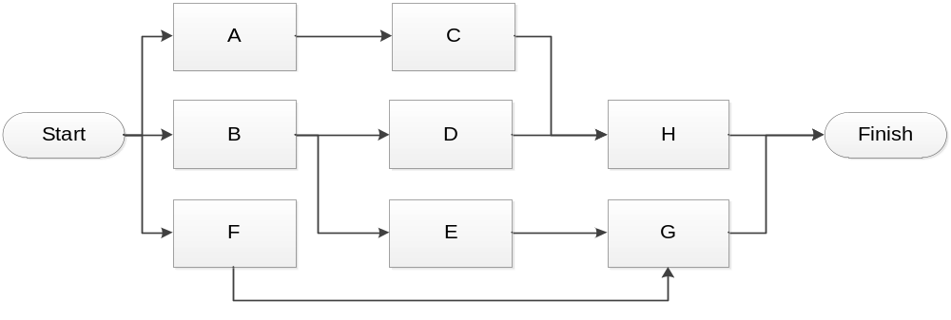
Task | a | m | b | t_{e} | s
A | 5 | 6 | 8
B | 3 | 4 | 5
C | 2 | 3 | 3
D | 3.5 | 4 | 5
E | 1 | 3 | 4
F | 8 | 10 | 15
G | 2 | 3 | 4
H | 2 | 2 | 2.5

- Calculate the expected time (te) and standard deviation (s) for each activity.
- Calculate the expected time and the z value for the project completion.
- What is the chance of not meeting the target date of the end of week 12?

Task 2: Below are details of a project. All times are in days
Activity | Depends on | Most likely | Plus safety/comfort zone
A |  | 10 | 14
B | A | 5 | 7
C | B | 15 | 21
D | A | 3 | 5
E | A | 8 | 12
F | E | 20 | 22
G | D | 6 | 8
H | C,F,G | 10 | 14

Draw up an activity diagram applying critical chain principles for this project
- Locate the places where buffers will need to be located
- Assess the size of the buffers
- Start all activities as late as possible

